NEOED PERFORM - EVALUATION PROGRAM CYCLE DETAILED GUIDE

STEP 1: Manager Sets Employee Goals
- Manager will get email to start evaluation cycle for Employee
- Click on link
- Add Goals (select from library or add new goal)
- Add Goal due date (recommend one month prior to rating period)
- Save
- Submit Content (yes, I’m finished)
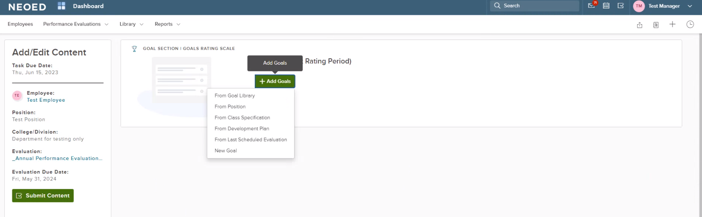
Add Goals from any of the links available.

STEP 2: Employee Acknowledges Goals
- Employee will get email to start evaluation cycle for Employee
- Click on link
- Review evaluation tool (performance criteria) and goals
- Select Sign button **See due date
- Submit
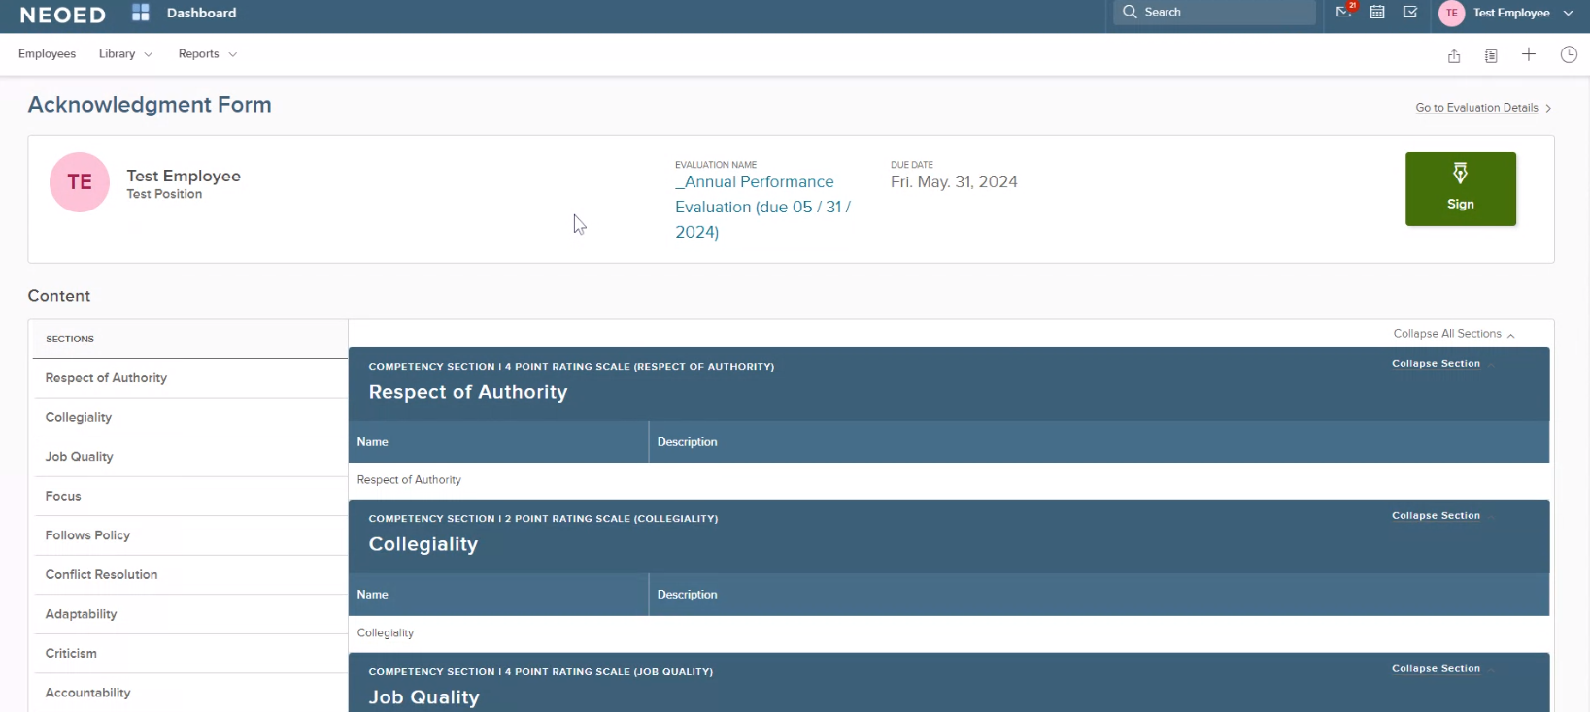

STEP 3: Manager Mid-Year Check-In (due December 31)
**REFER TO JOURNALING TRAINING GUIDE
- Manager will get email to complete mid-year check-in for Employee
- Click on link

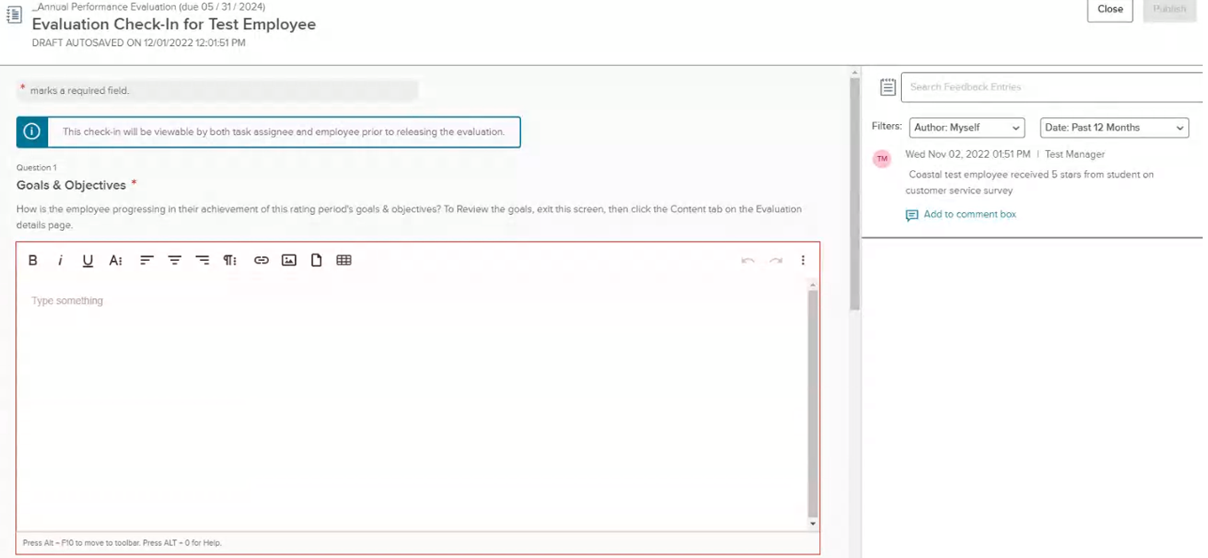
Insert comments in each section. A red * means a comment is required.

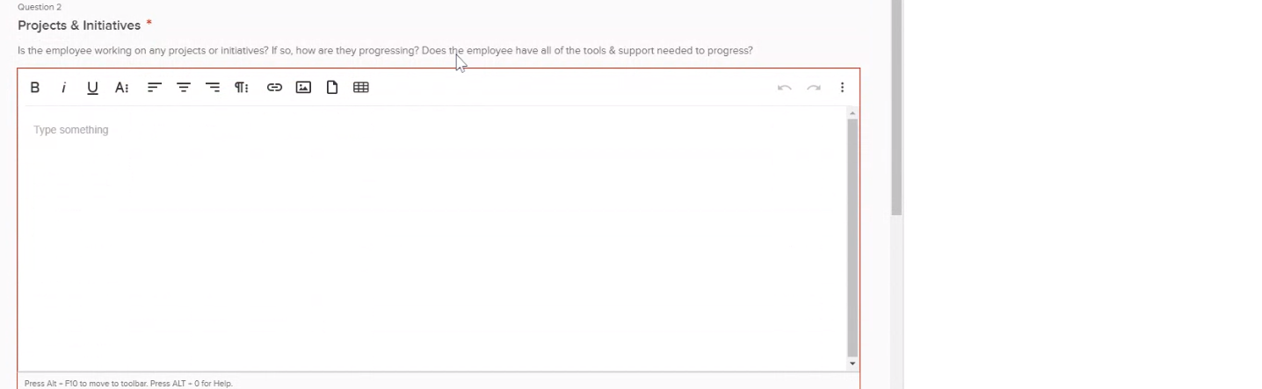
Insert comments in each section. A red * means a comment is required.
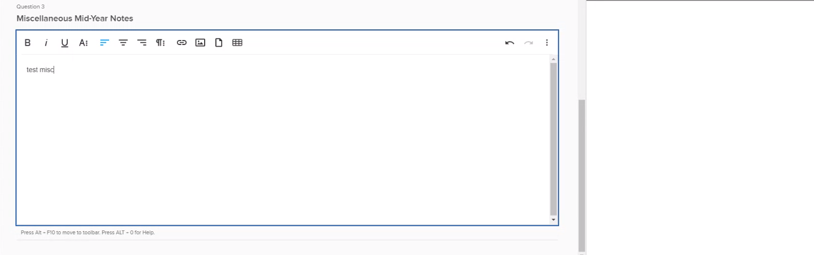
Insert comments in each section. A red * means a comment is required.

STEP 4: Manager Completes Employee Rating (Due April 30)
- Manager will get email to complete Employee rating
- Click on link
- Complete rating form for each rating criterion
- **Complete Supervisor and/or Instructor competencies, if applicable
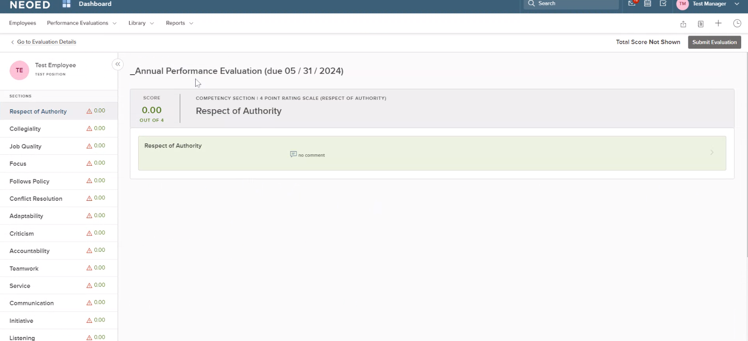
Rating criteria
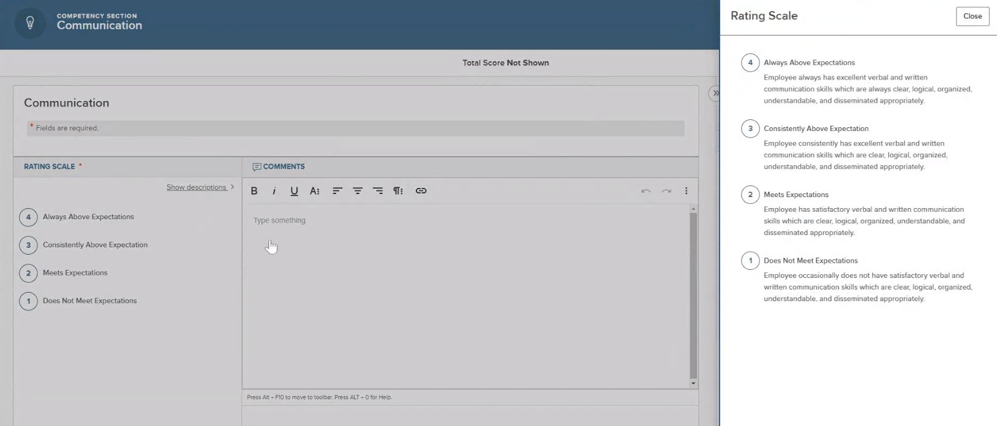
Always click the “Show descriptions” link to view the rating scale. Rating scales may be different for each criterion.

- Review Goals, Journal Entries, and Check-In Entries from beginning of Evaluation Cycle.
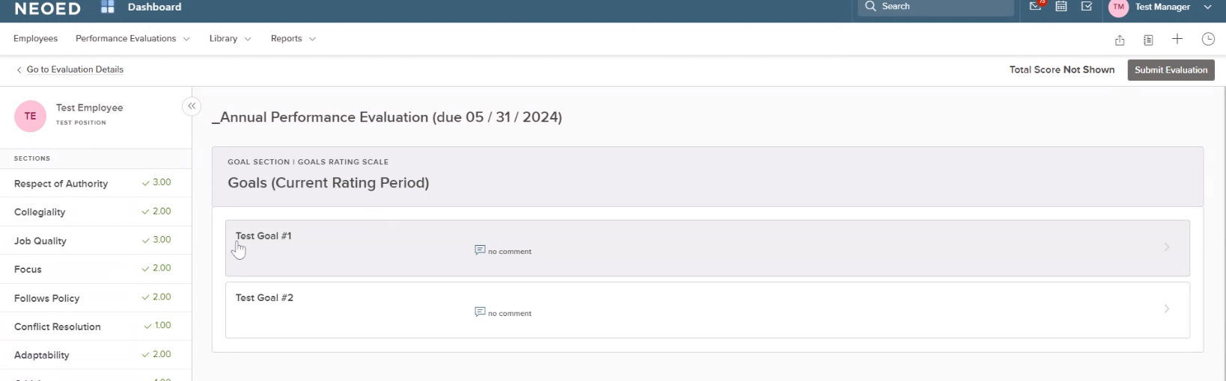
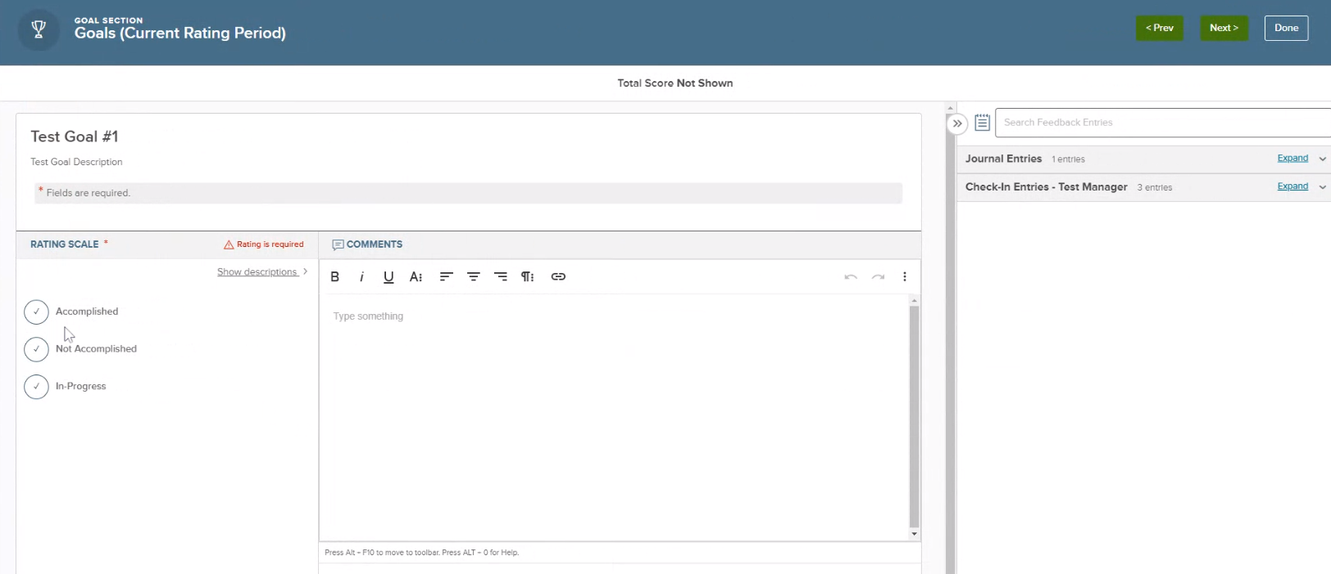
Review Journal Entries and Check-In Entries that Manager has completed throughout the performance evaluation period.

Review summary
Submit Evaluation button
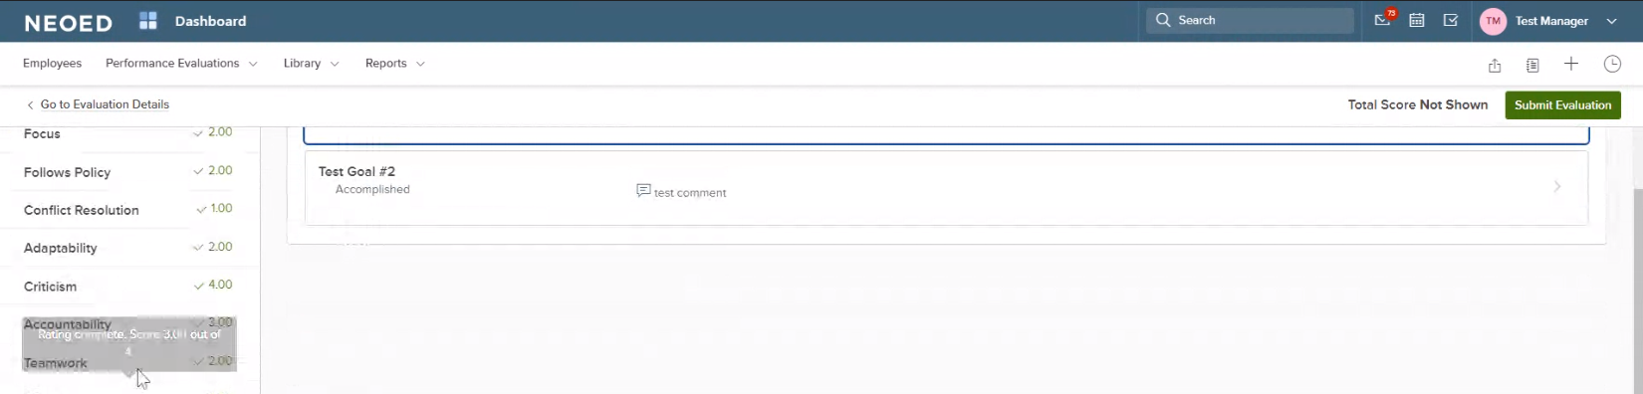

STEP 5: Next level Administrator Reviews/Signs (Due May 15)
- Next level Administrator (Manager’s Manager) will get email to complete Employee rating
- Click on link
- Review evaluation
- Approve & Sign button **Can Deny
- Submit
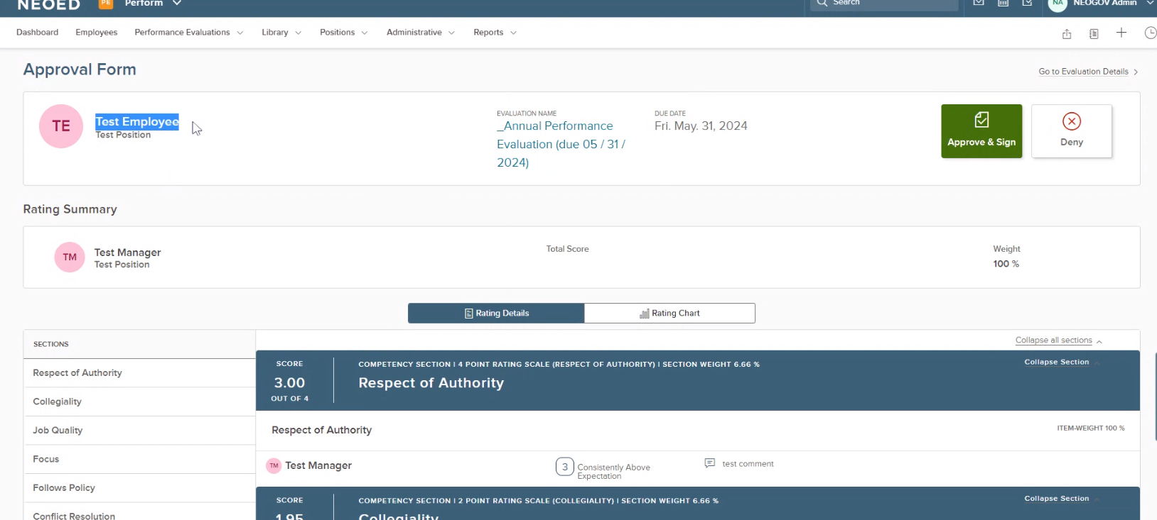

STEP 6: Manager Reviews/Signs (Due May 20)
- Manager will get email to sign evaluation
- Click on link
- Review evaluation
- Approve & Sign button
- Submit
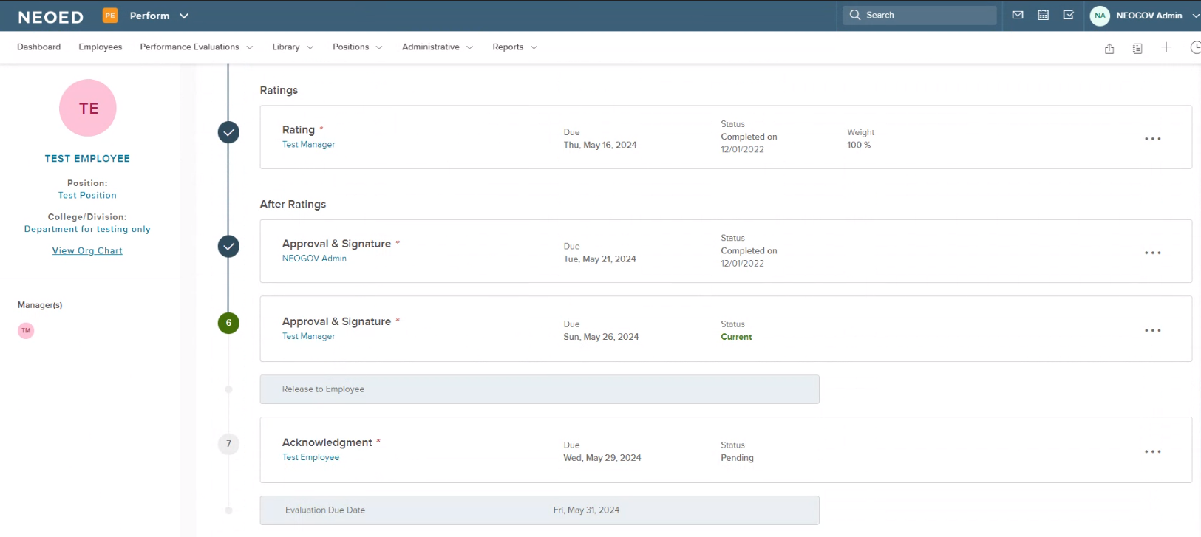

STEP 7: Employee Reviews/Acknowledges (Due May 31)
- Employee will get email to acknowledge evaluation
- Click on link
- Review evaluation
- Acknowledge button
- Submit **If Employee refuses to sign, manager will get an email notification.
