M/1.4-C

GSCC
NON-CAPITALIZED EQUIPMENT TRANSFER FORM
(For equipment not included on the annual inventory report)

MOVED FROM BUILDING:

ROOM NUMBER:

ITEM DESCRIPTION:

NUMBER OF UNITS:

EQUIPMENT CURRENTLY
ASSIGNED TO:
(Signature)

DATE:

Forward completed form to Property Manager

MOVED TO BUILDING:

ROOM NUMBER:

PERSON
RECEIVING:
(Signature)

DATE:

EQUIPMENT TRANSFERRED FROM:

EQUIPMENT TRANSFERRED TO:
GADSDEN STATE COMMUNITY COLLEGE EQUIPMENT/FURNITURE TRANSFER FORM FOR CAPITALIZED EQUIPMENT

(Name) (Date)

(Name)

First Item

Equipment Description | Moved From: Building Name |  |  | Room Number | GSCC  Tag No. | Serial Number
Moved To: Building Name |  | Room Number | Signature of Person Receiving
Second Item
Equipment Description | Moved From: Building Name |  |  | Room Number | GSCC  Tag No. | Serial Number
Moved To: Building Name |  | Room Number | Signature of Person Receiving
Third Item
Equipment Description | Moved From: Building Name |  |  | Room Number | GSCC  Tag No. | Serial Number
Moved To: Building Name |  | Room Number | Signature of Person Receiving

ORIGINAL TO:
Property Manager
I am currently charged with the responsibility for the above listed items and request that the above transfers be made as indicated:

Signature Date

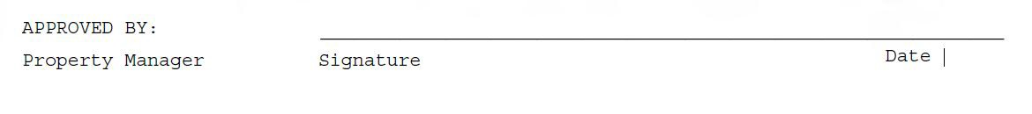

Instructions for Equipment/Furniture Transfer Form:

- The person requesting that a transfer of equipment be completed should fill out the top portion of the transfer form. This lets the maintenance employees know who to pick up the equipment from, and who to deliver it to.
- List each item to be transferred separately. (Ex. 2 welding stations should be listed as two separate items.) Each piece of equipment has a different tag number, and must be tracked in the system separately.
- List each item that needs to be transferred by giving the description, building and room where the item is currently located, the GSCC inventory tag number, the item’s serial number, and the building and room that the item will be moved to.
- Sign the form indicating that the transfer is being requested, and forward to the Property Manager.
- The Property Manager will sign the form granting approval andcontact a maintenance employee to actually move the equipment. The maintenance employee will bring the transfer form to let them know where to pick up and deliver the equipment.
- Once the equipment has been physically moved, the employee who has received the equipment should sign beside each item received.
- A maintenance employee will return the signed form to the Property Manager. NOTE: IF YOU ARE MOVING A CAPITALIZED ITEM, EVEN FROM A CLASS TO ADJOINING LAB, THIS FORM MUST BE COMPLETED AND APPROVAL MUST BE OBTAINED.

