SECTION: Gadsden State Community College Vision, Mission, Beliefs, Pillars, and Strategic Plan NUMBER: A/1.2
SUBJECT: Vision, Mission, Beliefs, Pillars, and Strategic Plan
SOURCE REFERENCE: Gadsden State 2024 – 2027 Strategic Plan

Vision Statement

Gadsden State Community College will be the preferred choice for exceptional education and innovative workforce development which changes the lives of our students, their families, and our world for good, forever.

Mission Statement

Gadsden State Community College empowers and prepares students from all backgrounds for success through exceptional education and innovative workforce development with a focus on community and global engagement resulting in a positive economic impact for all stakeholders.

Core Beliefs

EXCELLENCE
Committed to a culture that empowers all to achieve high standards
ACCOUNTABILITY
Focus on continuous improvement through the use of data-informed decisions
RESPECT
Value each other
SERVICE
Keep the needs of others at the heart of our work
INTEGRITY
Adherence to moral and ethical principles

Institutional Pillars / Major Goals

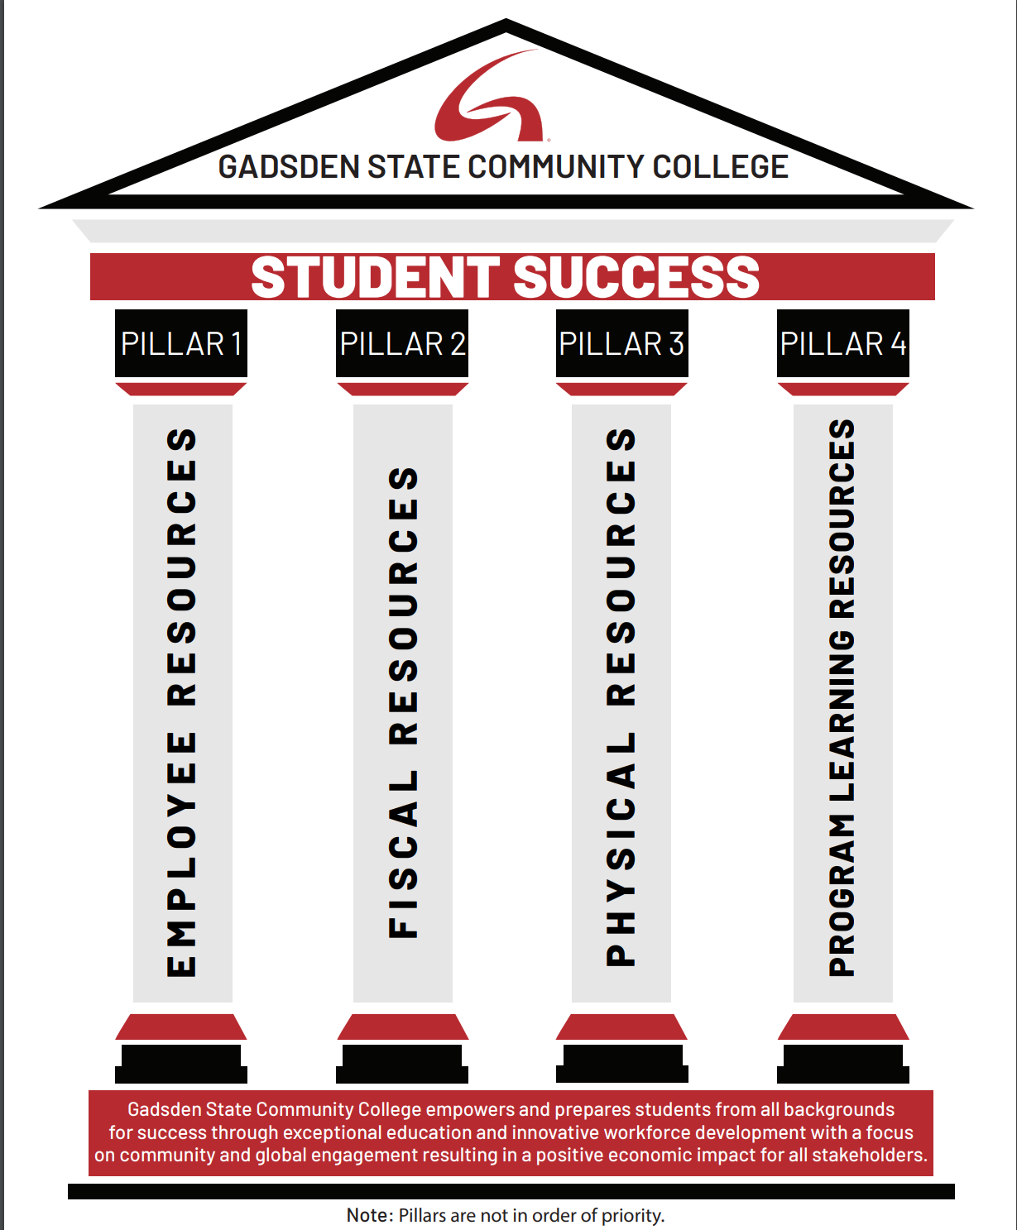

Strategic Plan

Link to Gadsden State Strategic Plan
